SQL Notes

* **SELECT** - extracts data from a database
* **UPDATE** - updates data in a database
* **DELETE** - deletes data from a database
* **INSERT INTO** - inserts new data into a database
* **CREATE DATABASE** - creates a new database
* **ALTER DATABASE** - modifies a database
* **CREATE TABLE** - creates a new table
* **ALTER TABLE** - modifies a table
* **DROP TABLE** - deletes a table
* **CREATE INDEX** - creates an index (search key)
* **DROP INDEX** - deletes an index

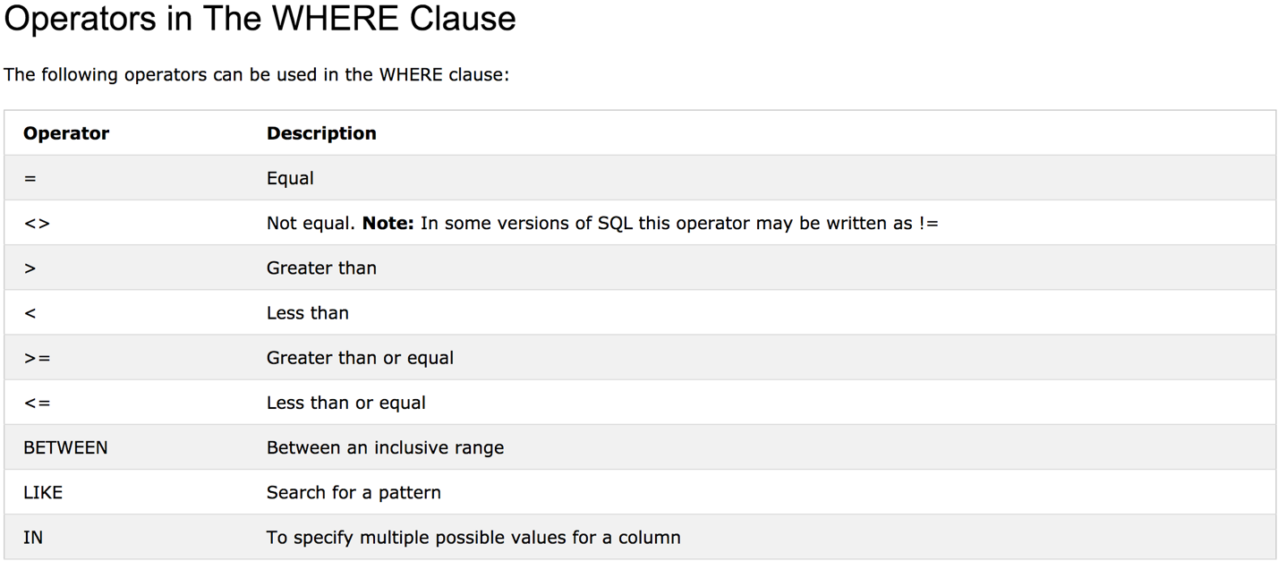

**ORDER BY DESC Example**

The following SQL statement selects all customers from the "Customers" table, sorted DESCENDING by the "Country" column:

SELECT * FROM Customers  
ORDER BY Country DESC;

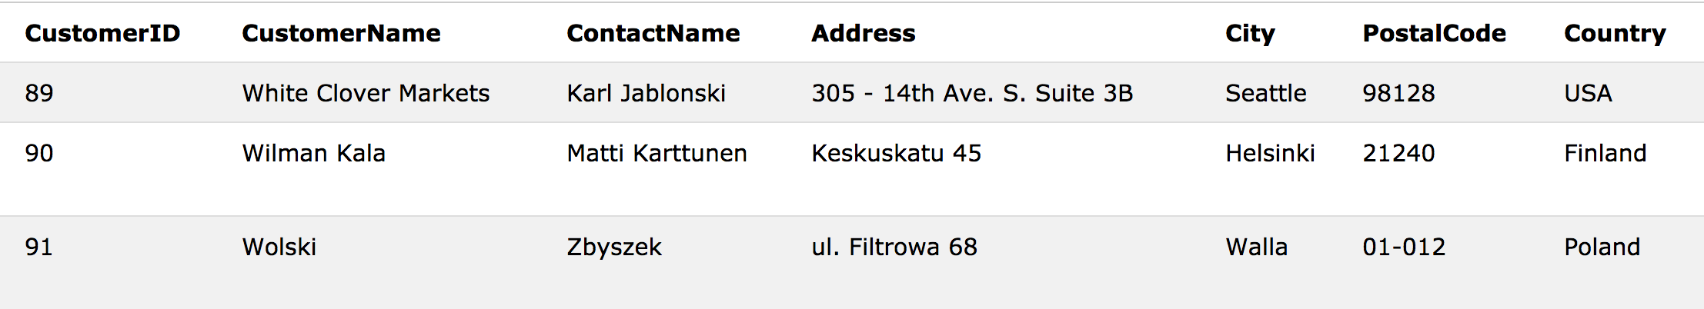

INSERT INTO Customers (CustomerName, ContactName, Address, City, PostalCode, Country)

VALUES ('Cardinal','Tom B. Erichsen','Skagen 21','Stavanger','4006','Norway');

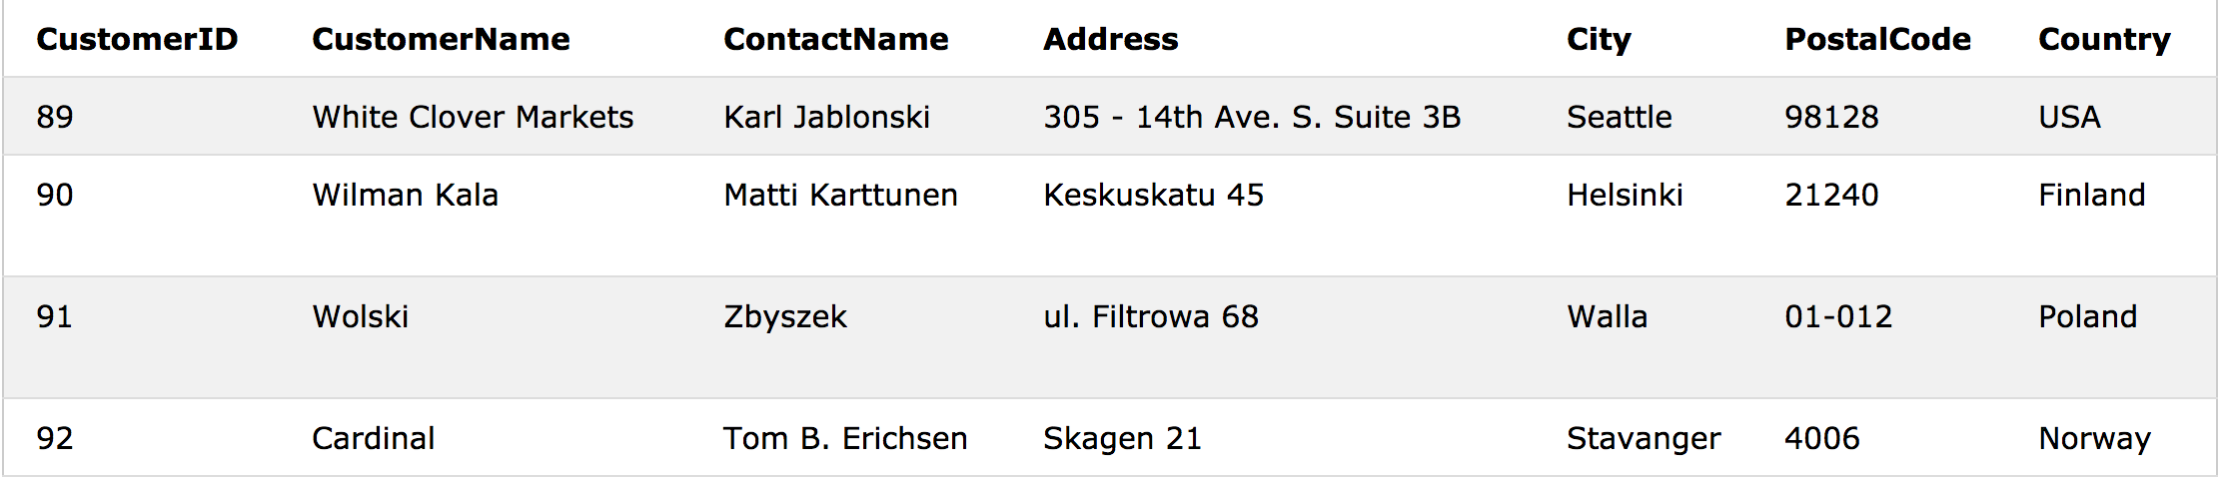

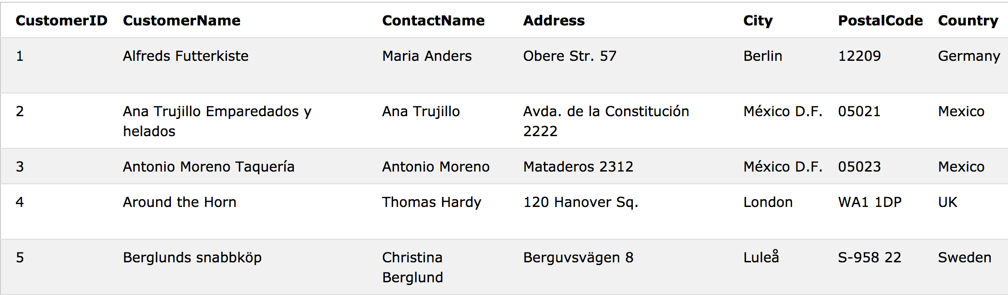

UPDATE Customers  
SET ContactName = 'Alfred Schmidt', City= 'Frankfurt'  
WHERE CustomerID = 1;

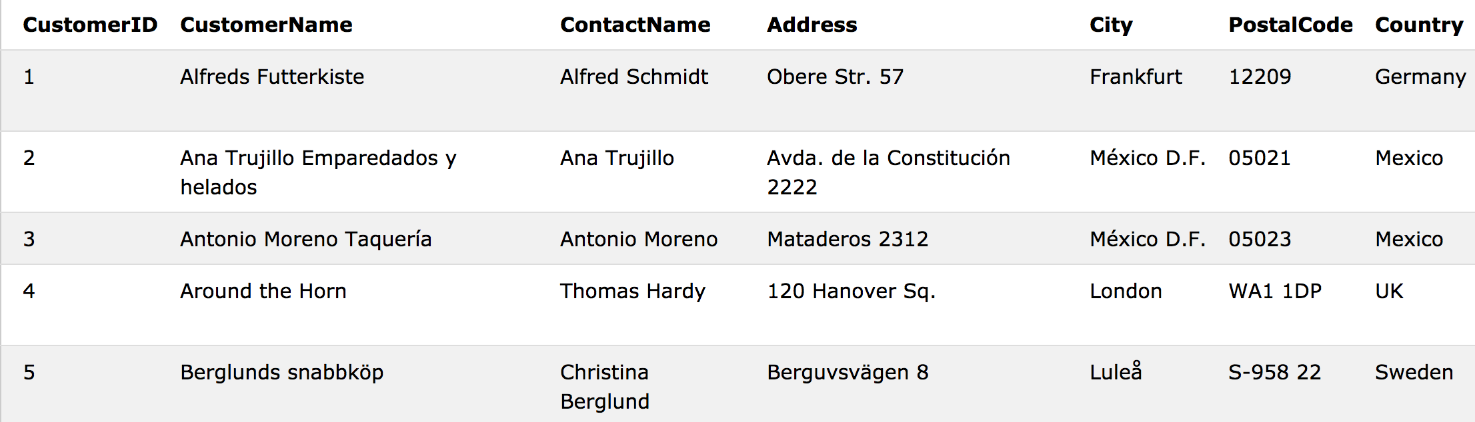

UPDATE Customers  
SET ContactName='Juan'  
WHERE Country='Mexico';

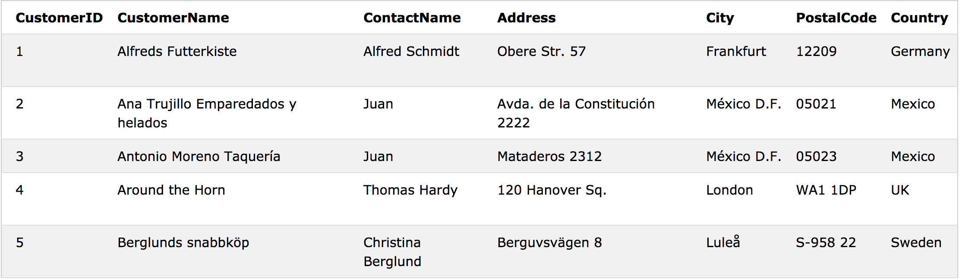

UPDATE Customers  
SET ContactName='Juan';

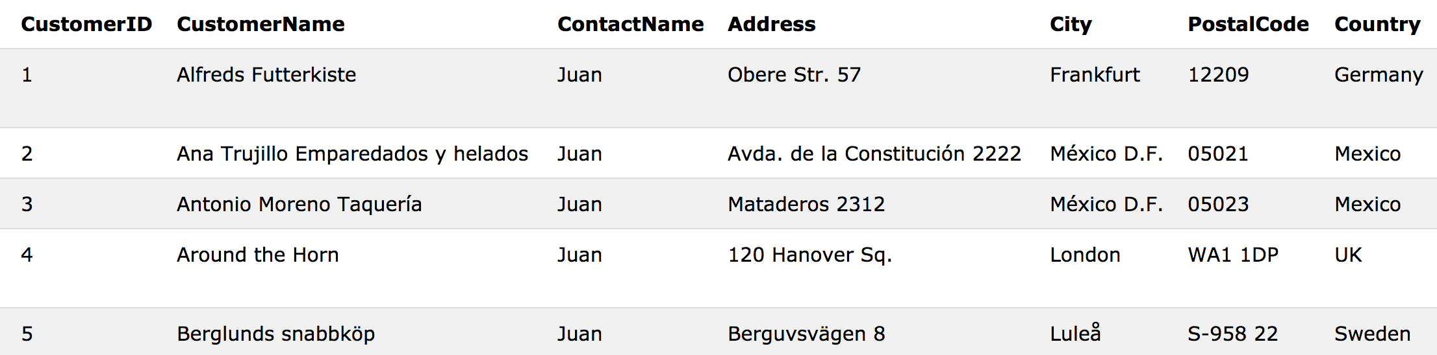

**SQL STOPPED AT UPDATE**